**REGIONAL BUSINESS CONFERENCE**

**"ECONOMIC PARTNERSHIP AND BUSINESS DEVELOPMENT IN THE BURGAS REGION"**

**18.09.2025**

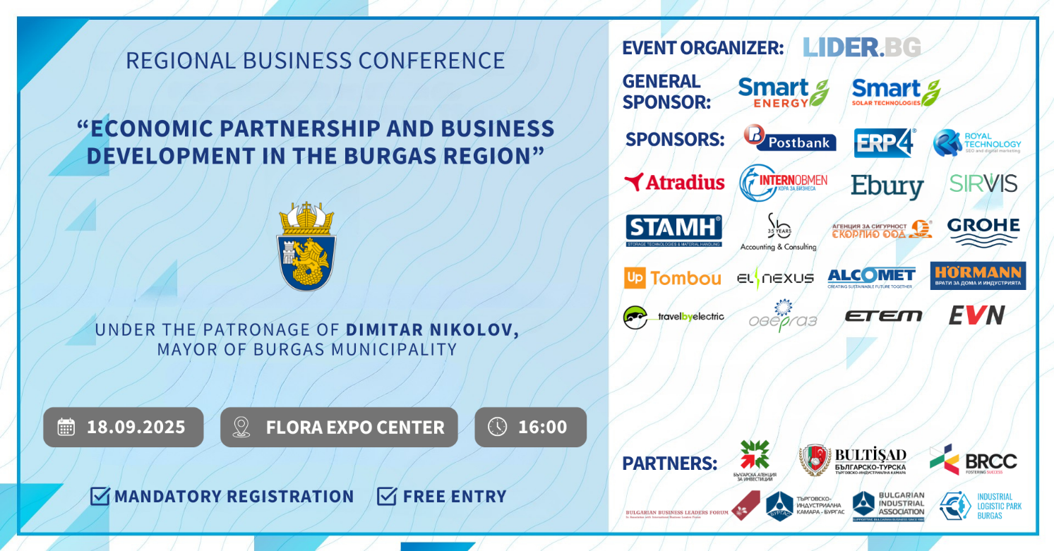

**DRAFT PROGRAM**

**🕒 16:00 – Opening of the Conference by the Mayor of Burgas Municipality – Dimitar Nikolov**

* **Welcome Address by Mr. Krasimir Yakimov** – Deputy Minister of Innovation and Growth (TBC)
* **Welcome Address by Mr. Tolga Orkun** – Consul General of the Republic of Turkey in the Republic of Bulgaria
* **Welcome Address by Mrs. Iliyana Ilieva** – Executive Director of the Bulgarian-Romanian Chamber of Commerce
* **Welcome Address by Ms. Bilyana Georgieva** – CEO of Lider.BG and event organizer

**🕒 16:30 – Part One: Investment Potential of Burgas Region**

* **Burgas Municipality** – Long-term Development Strategy of the region
* **Mila Nenova, Bulgarian Investment Agency –** Encouraging investments in the region – (TBC)
* **Stefan Trifonov, Electra Airways –** (TBC)
* **Dimitro Zaharchenko, Prometstil -** (TBC)

**🕒 17:30 – Part Two: New Growth Opportunities**

* **Smart Solar –** Svetoslav Mladenov, CEO
* **Postbank –** Vladimir Dimitrov, Head of Sales Management Unit, BMB Segments & Sales Department
* **Vivacom –** Kaloyan Borovinov, Manager “ICT projects” (**TBC**)
* **Atradius –** Vladimir Vachkov, Country Manager for Bulgaria
* **Hormann –** Boris Glavchovski, General Manager
* **Sb Accounting & Consulting -** Representative
* **Ebury –** Svetoslav Georgiev, Commercial Director
* **Stamh –** Vladimir Shokordov, Commercial Director
* **InternObmen –** Nikoleta Ivanova, Commercial Director
* **Sirvis -** Representative
* **TravelByElectric –** Denitsa Daverova, Executive Director
* **Security Agency "Scorpio" –** Kamen Penkov, Commercial Director
* **EVN –** Representative
* **ERP4.**bg - Representative

**🕒 17:30 – Networking Session and Business Expo**

Explore company booths from:  
📌Grohe, Overgas, Up Tombo, ElNexus, Borica (TBC)

🚗 **Special participation by …………….**

**🕒 19:30 – Conference Closing**