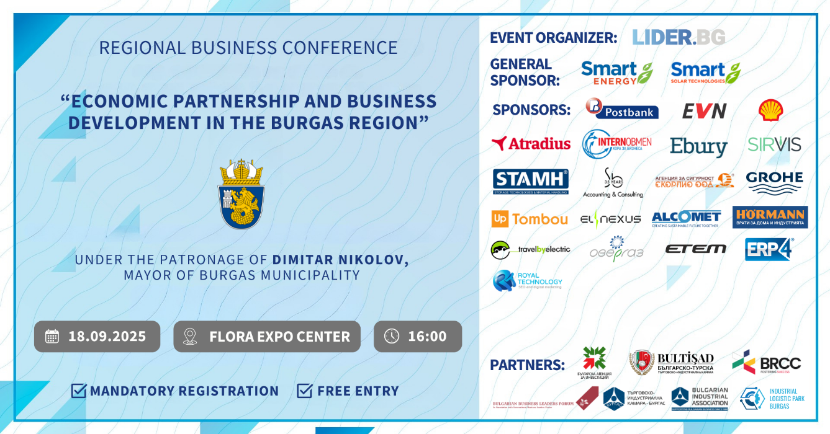**REGIONAL BUSINESS CONFERENCE – BURGAS 2025**  
📅 September 18, 2025 | 🕑 From 16:00 | 📍Flora Hall

***Burgas Municipality: Strategic Industrial and Investment Hub***

The ***Municipality of Burgas*** is one of the most dynamically developing industrial and economic centers in Bulgaria, distinguished by its favorable geostrategic location on the Bulgarian Black Sea coast. This provides excellent transport, logistics, and commercial infrastructure – including an international airport, a seaport, and access to major land transport corridors.

Burgas has a well-developed industrial sector and several large industrial zones that offer suitable conditions for high-tech and modern manufacturing. The region hosts projects in green energy, innovation, and sustainable development.

The Municipality of Burgas actively works to improve the business environment and attract both foreign and local investors, making it an attractive destination for investment and new business ventures.

The purpose of the ***Lider.bg Regional Business Conference in Burgas*** is to create a strategic platform for attracting investors and stimulating sustainable business development in the region. The event aims to bring together representatives of the local and international business community, institutions, and experts to exchange best practices, generate new opportunities, and establish lasting business collaborations and partnerships.

The conference focuses on unveiling ***the potential of Burgas*** as an industrial and economic center, encouraging investment initiatives and innovations that will support the socio-economic development of the region.

During the conference, innovative solutions and services from leading companies on the Bulgarian market will be presented, providing businesses with up-to-date and valuable information. These presentations will be delivered by the major participating companies, offering an opportunity for direct contact and experience exchange among all attendees.

The event is held under the patronage of Mr. Dimitar Nikolov, Mayor of Burgas Municipality, in partnership with [Burgas Municipality](https://www.burgas.bg/), [Ministry of Innovation and Growth](https://www.mig.government.bg/), [Bulgarian Investment Agency](https://investbg.government.bg/), [Bulgarian-Turkish Chamber of Commerce and Industry](https://bgtrchamber.org/bg/homepage-bg/), [Bulgarian-Romanian Chamber of Commerce](https://brcc.bg/bg), [Chamber of Commerce and Industry – Burgas](https://bourgas.bia-bg.com/), [Industrial and Logistics Park – Burgas](https://www.industrialpark-burgas.bg/bg), and with the support of the [Bulgarian Industrial Association](https://bia-bg.com/), [Bulgarian Chamber of Commerce and Industry](https://www.bcci.bg/), [Bulgarian Business Leaders Forum](https://www.bblf.bg/), and other representatives of the business and institutional community.

The general sponsor of the event is [SMART ENERGY](https://www.smartsolar.bg/) – a leading company in the construction of turnkey photovoltaic power plants, as well as in the production and sale of electricity.

Sponsors and participants of the event include leading Bulgarian and international companies such as [POST BANK](https://www.postbank.bg/), [ATRADIUS](https://atradius.bg/), Shell, [InternObmen](https://internobmen.bg/), [HÖRMANN Bulgaria](https://www.hormann.bg/), [Sb Accounting & Consulting](https://sb-bg.com/bg/), [SIRVIS](https://www.sirvis.bg/), [Ebury](https://www.ebury.bg/), [ALCOMET](https://www.alcomet.bg/), [STAMH](https://stamh.com/bg), [travelbyelectric](https://travelbyelectric.com/), [Security Agency “Scorpio”](https://www.scorpio-bg.com/bg), [GROHE](https://www.grohe.bg/bg_bg/), [Overgas](https://www.overgas.bg/), [Up Tombou](https://uptombou.bg/), [ElNexus](https://elnexus.bg/), [Royal Technology](https://www.royaltech.bg/bg), [ERP4.bg](http://erp4.bg/), [ETEM](https://etem.com/bg), [EVN](https://www.evn.bg/).

**Why attend?**✔ Presentation of innovative solutions and successful business models  
✔ Opportunity for direct contact with business leaders and institutional representatives  
✔ Real meetings with investors and partners from Bulgaria and abroad  
✔ Access to up-to-date information on investment prospects and growth strategies

📅 **Date: September 18, 2025, 16:00**📍 Location: Expo Center "Flora," Burgas  
💶 Entrance: FREE  
🎟 Registration: Mandatory registration at 🔗<https://lu.ma/cgp91lhv>

**Your presence would be highly valued and will contribute to strengthening the business dialogue and economic development of the region.**

**Sincerely,**  
*The Team of Burgas Municipality & Lider.bg*